**Formative Assignment 2**

|  |  |
| --- | --- |
| Module Name | Front End Development & Programming |
| Course Name | Applied Master in Software Engineering/ Post Graduate Certificate in Software Development/ Skills Certificate in Software Development |
| Assignment Title | Website Development – 1 |

|  |  |
| --- | --- |
| Learner Name | Umar Bin Kasan |

|  |
| --- |
| Learner declaration |
| I certify that the work submitted for this assignment is my own and research sources are fully acknowledged.  Student signature: Umar Kasan Date: 09/10/2022 |

Contents

Home Page 3

About Us 4

Book Catalogue 5

Find Us 6

Log In 7

Profile 8

Register 10

Borrowers List 11

# Home Page

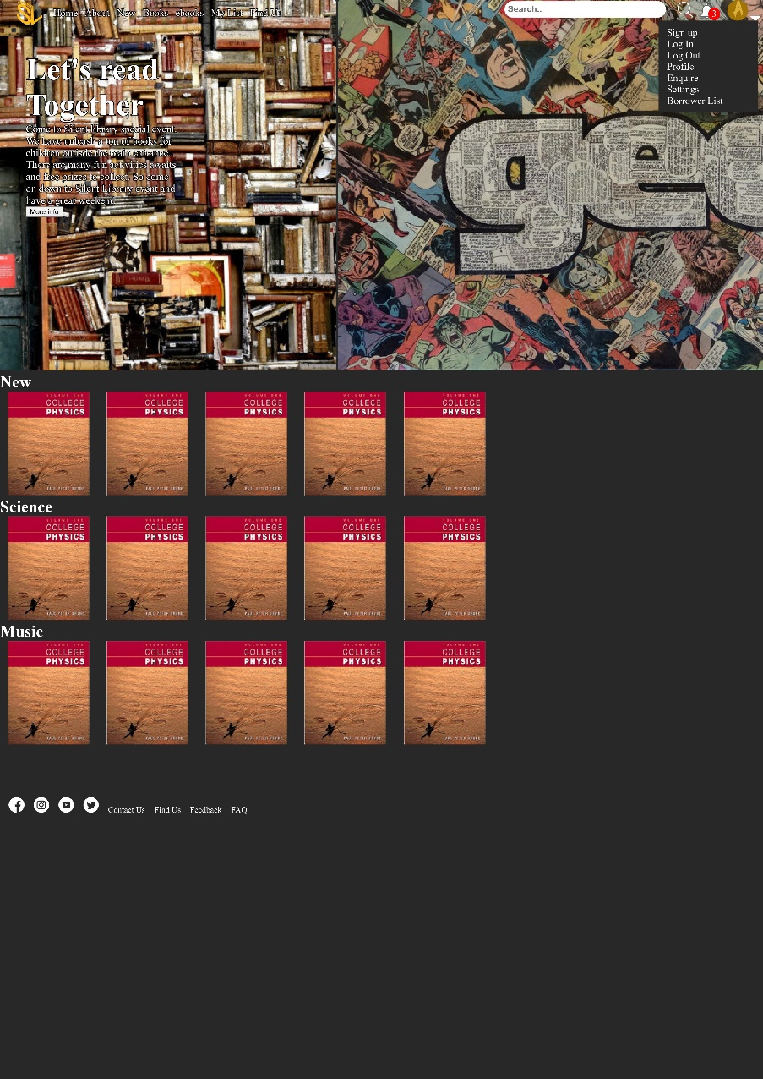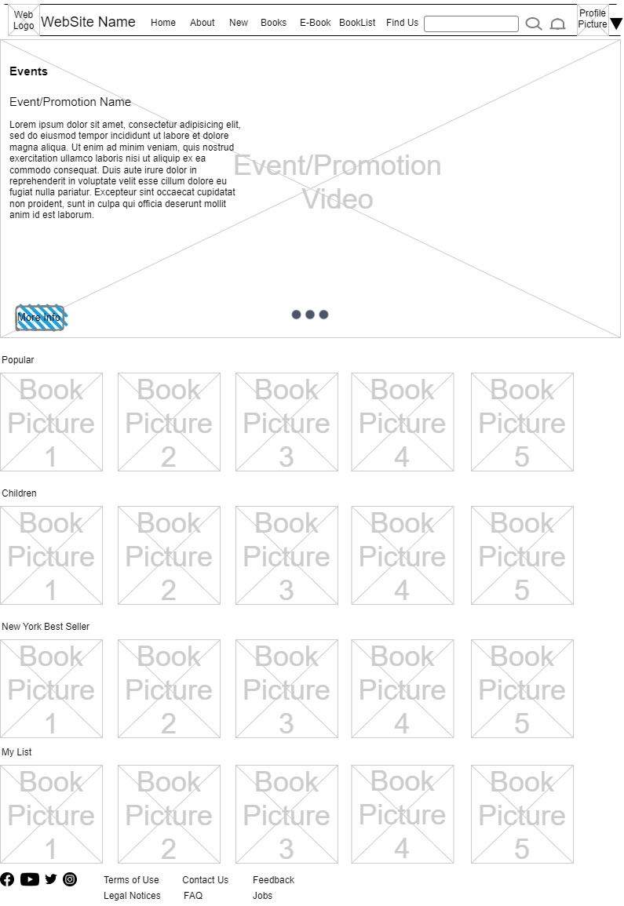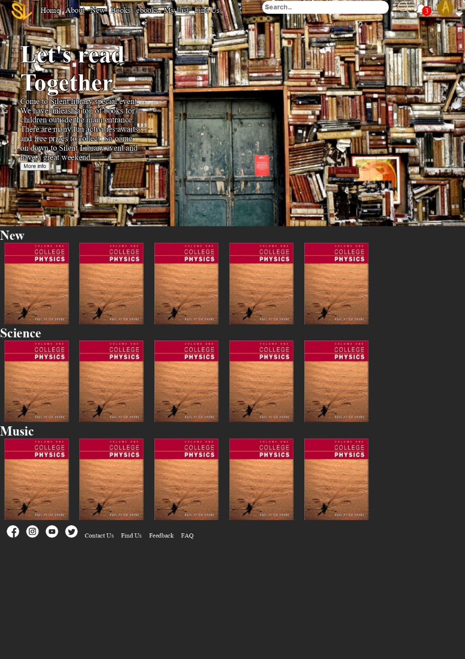

Updates

* Added Text Shadows in CSS to create Clarity in Text
* Made Navigation bar Fixed on top of browser
* Updated Silent Library logo for visual appeal
* Made a CSS carousell to events
* navigation bar

Future improvements

* Add gradient/ background colour to navigation bar
* Add more contents to footer
* Improve on carousell
* Make opaque background to improve readability of text on Image background

Website

Wireframe

# About Us

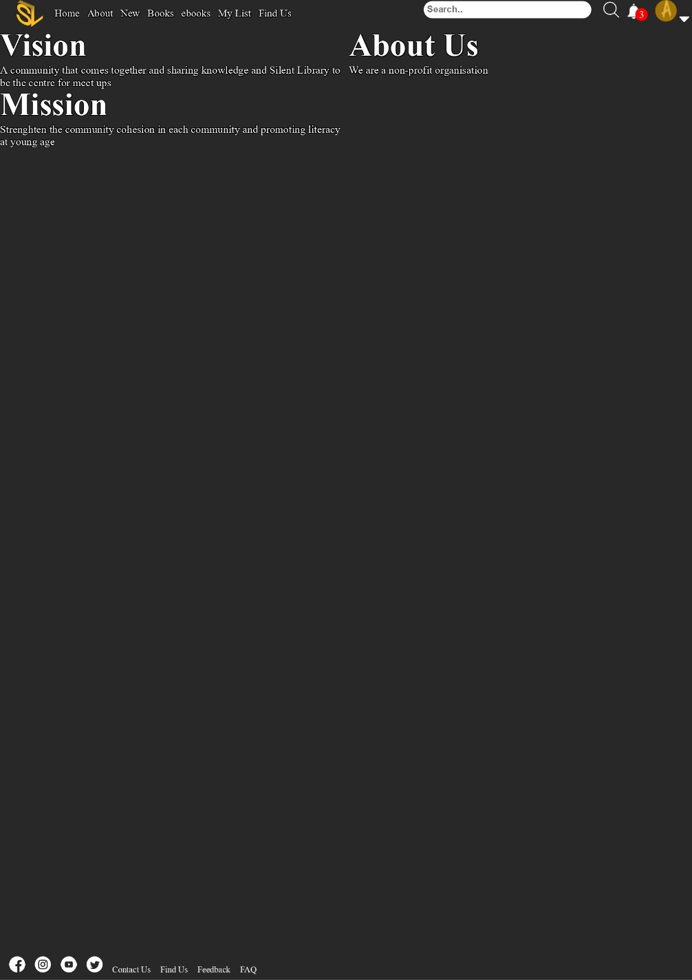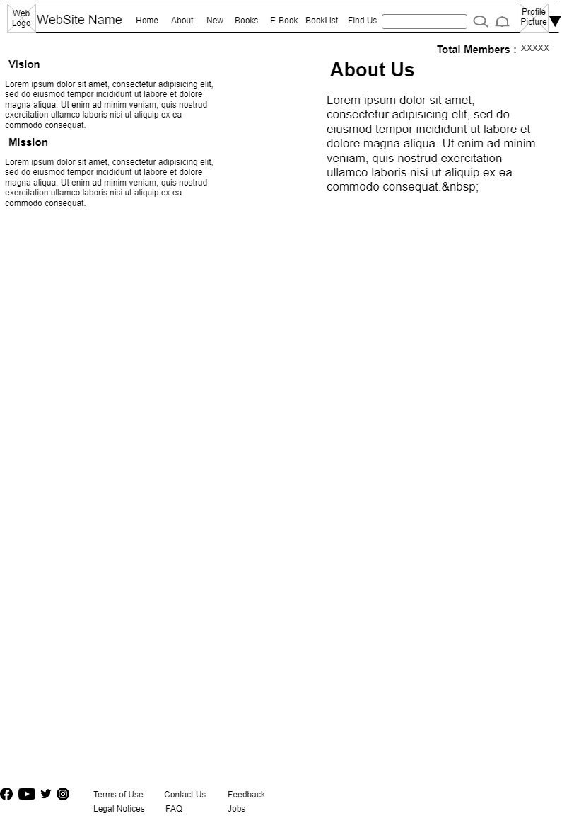

Updates

* Created Auto Grid so it will be responsive in different screens

Future Improvements

* Add more Contents in the future

Webpage

Wireframe

# Book Catalogue

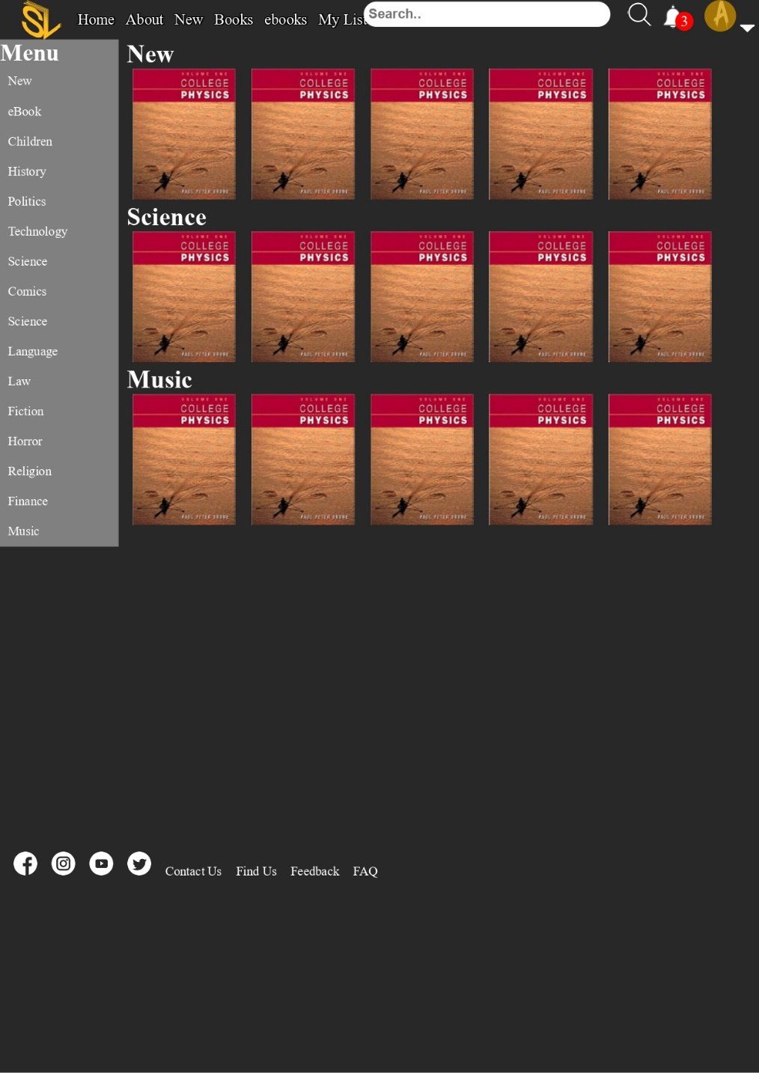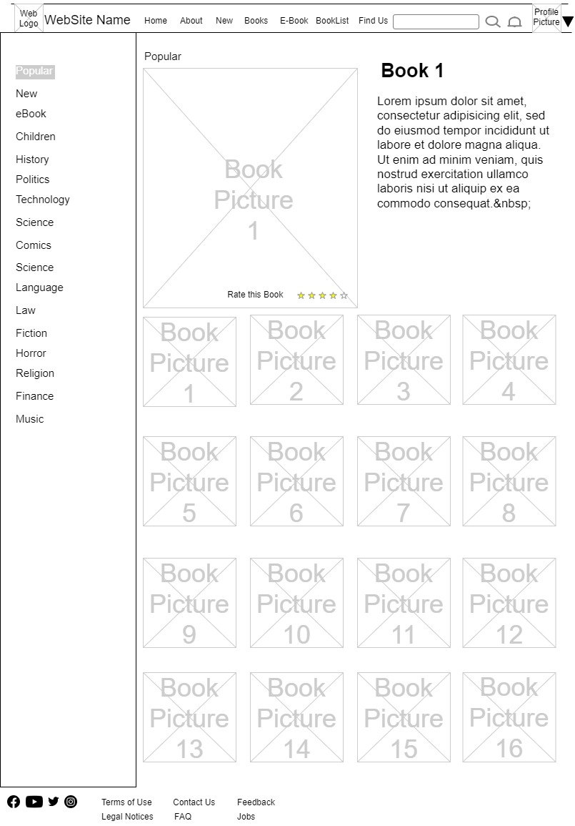

Webpage

Updates

* Created Auto row so that the list of books will be shown in a row

Future Improvements

* To auto resize the photo of books
* Auto hide books if exceed row
* Make a Responsive enlarge portion when book is selected
* Add GET to Fetch Titles and description on each book
* Improve Filter using Javascript

Wireframe

# Find Us

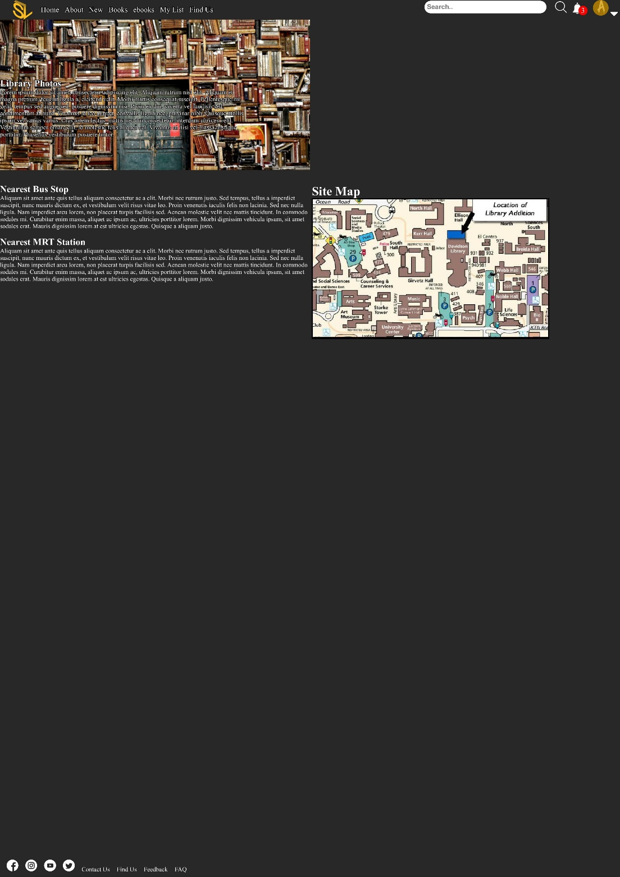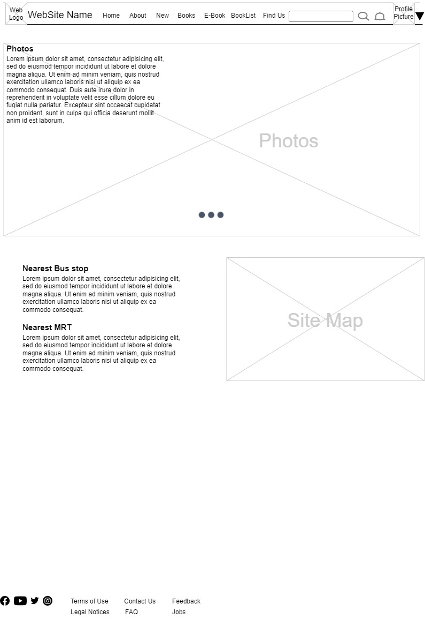

Webpage

Updates

* Static page of pictures and Text

Future Improvements

* Add Carousell to Library Photos
* Add Google map API on site map, to enable more findability functions to get to the library

# Log In

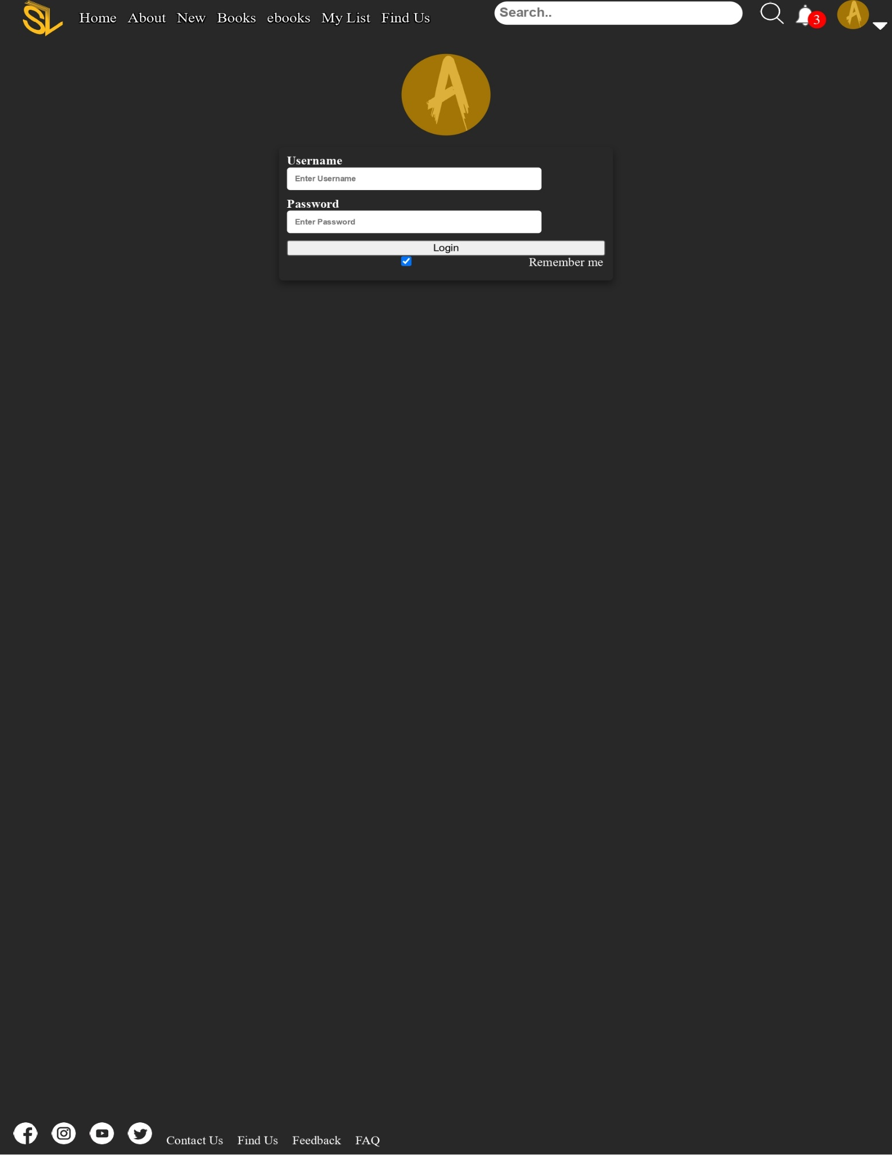

# Profile

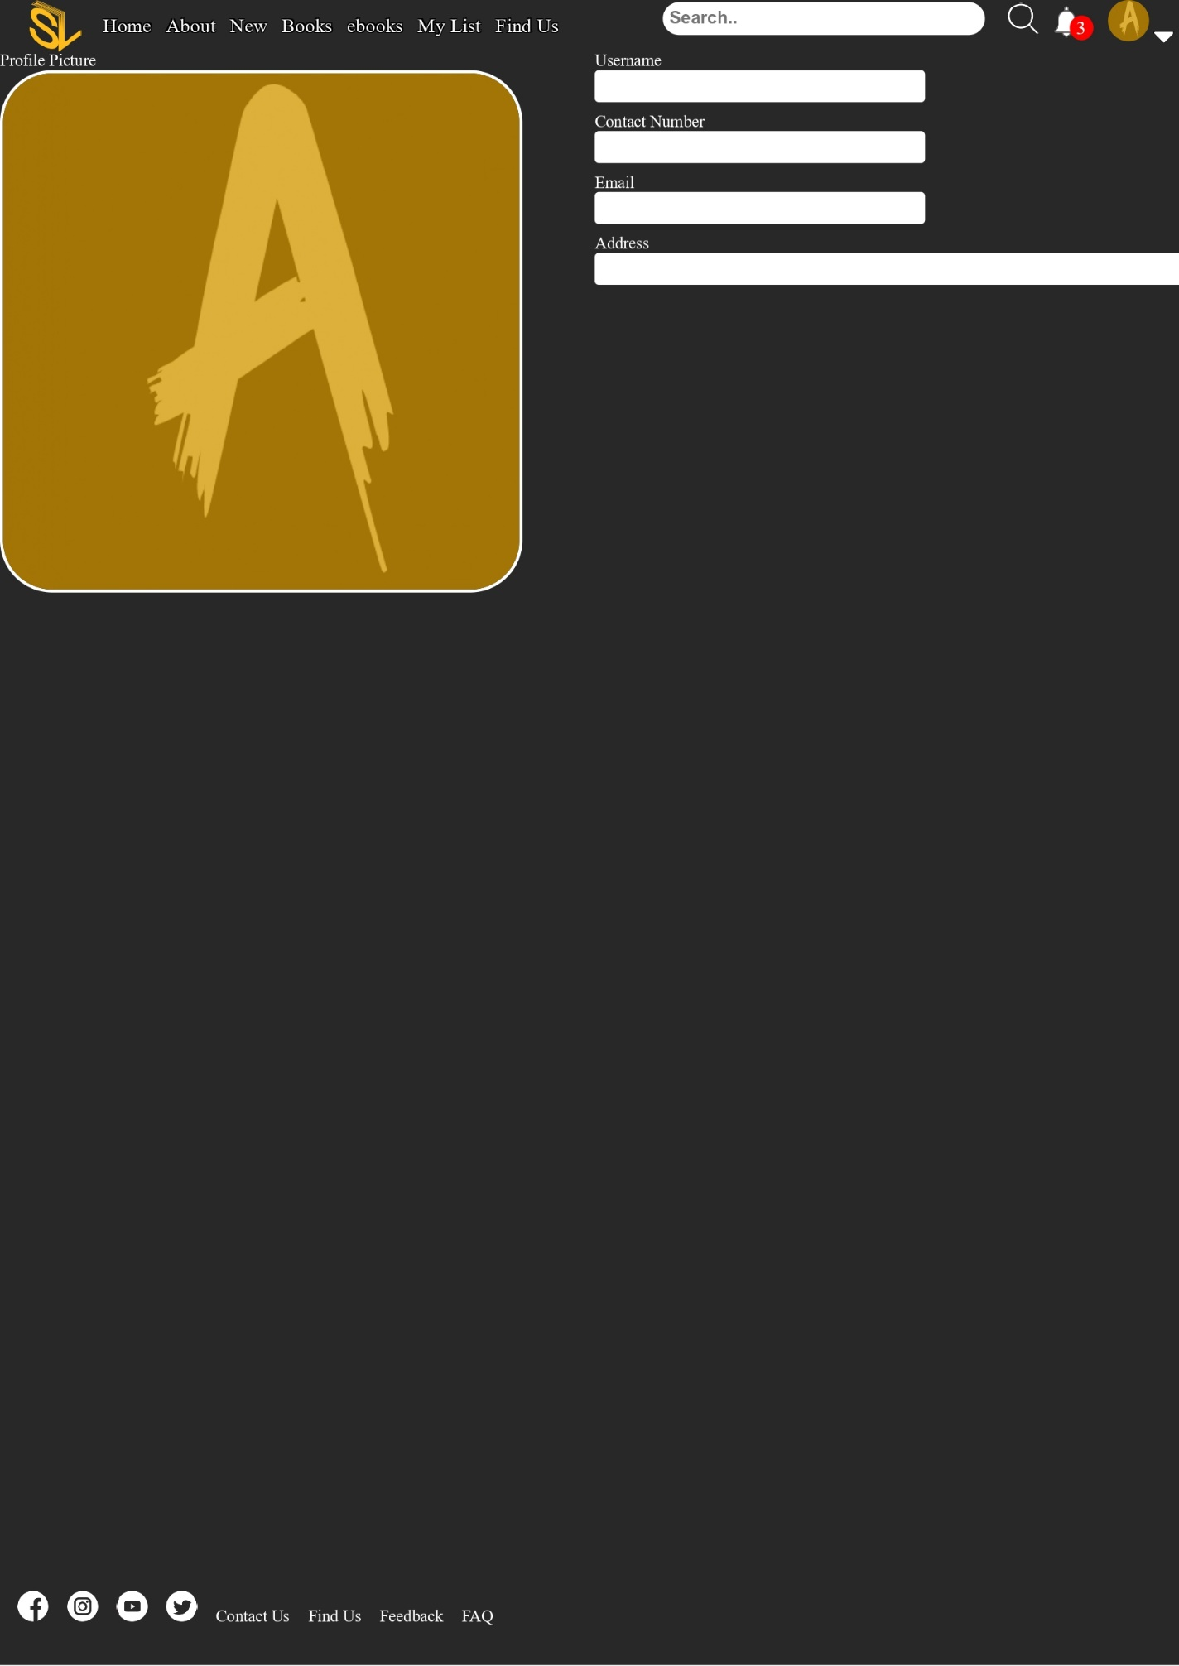

# Register

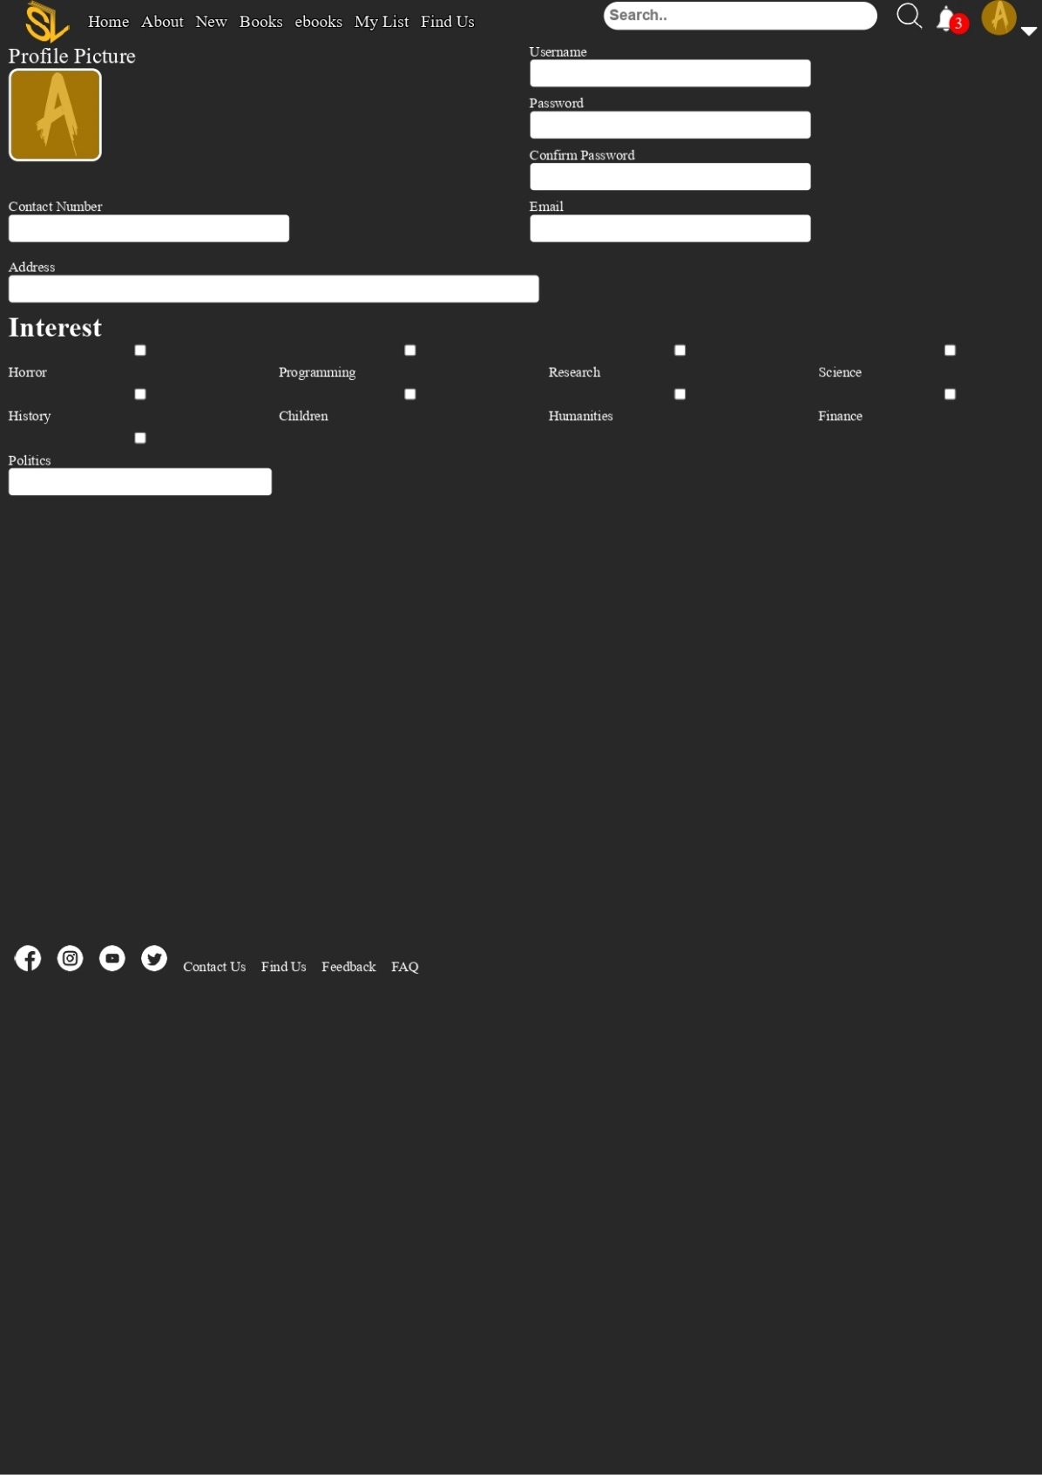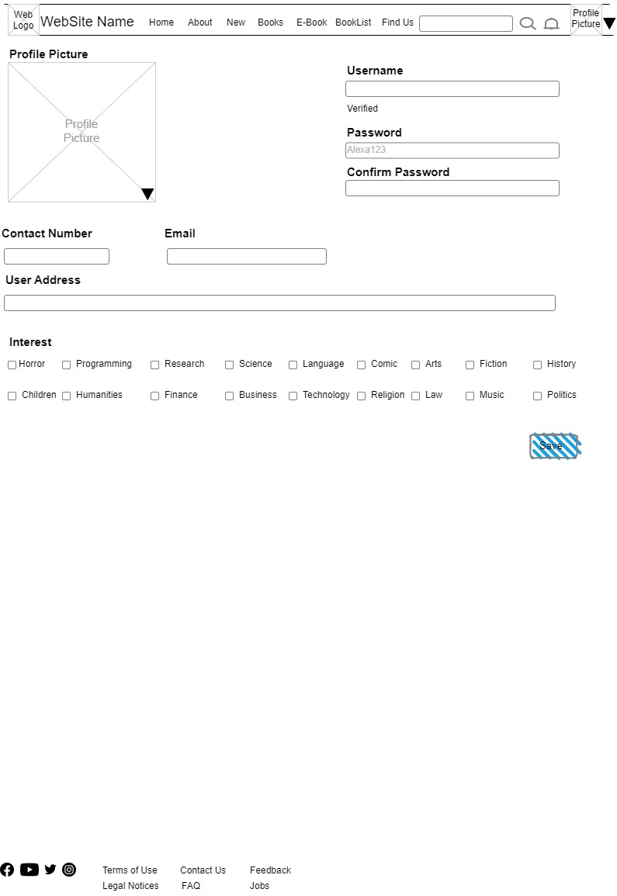

Webpage

Updates

* Add check boxes
* Input and labels

Future Improvements

* Register and make it dynamic with Javascript

Wireframe

# Borrowers List

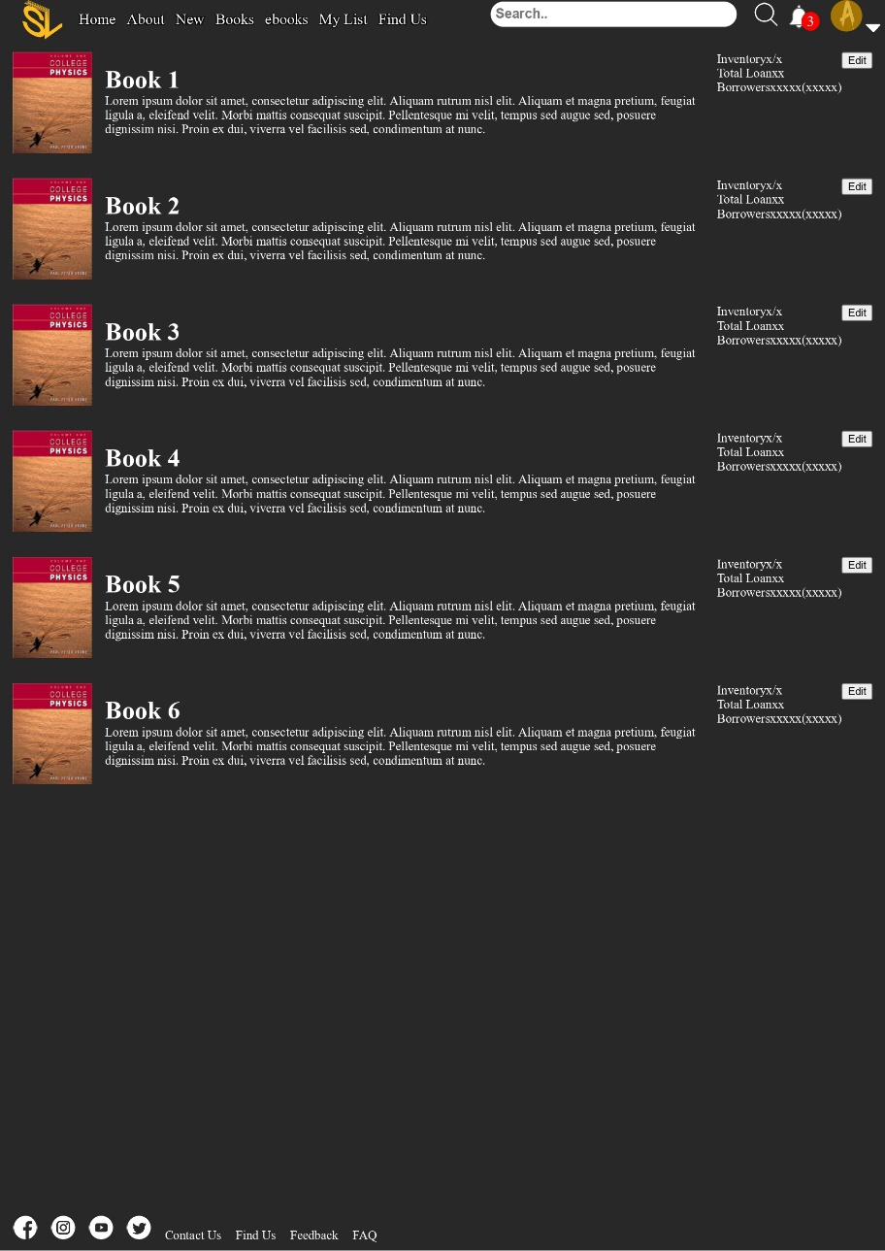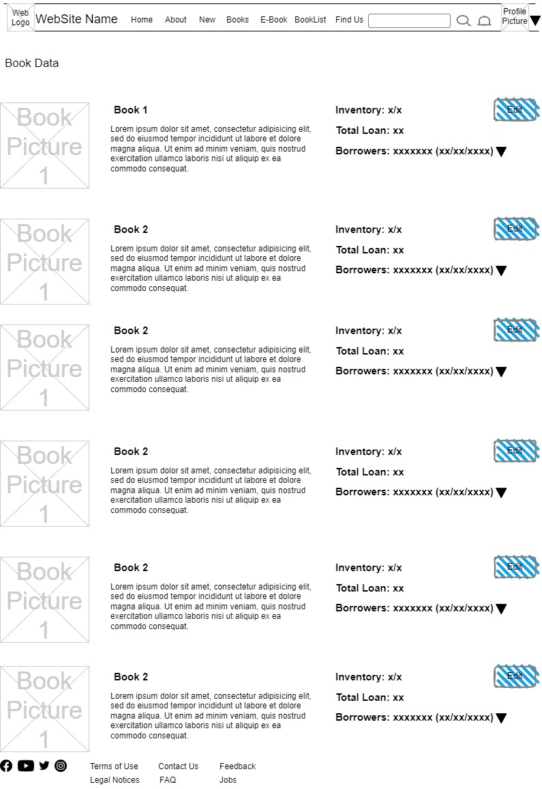

Wireframe

Updates

Add check boxes

Input and labels

Future Improvements

* Register and make it dynamic with Javascript

Webpage